Homework 5: All about Files
PART I: Basic File I/O 8 points ( 2 pts each)
Write a Program to create a text file for writing. Use fprintf() to write a simple text message such as “Hello\n” to the file and close it. Now re-open it in read mode and determine the following:
- Whether or not the ‘\n’ character is translated into a line feed sequence. .
Yes, the \n character is translated.
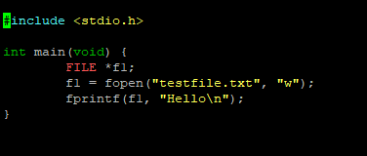
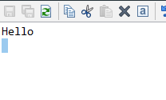
Close the file. Next, open the file in append mode.
- Determine whether the SPI is positioned at the start or end of the file when an existing file is opened in append mode. You can use ftell()/fseek() for that;

SPI is at end of file.
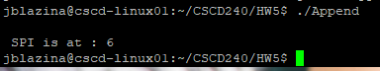

- In append mode, try to use fseek() to move SPI at the beginning. Then write “Goodbye CSCD240\n” in the file. Does it write at the beginning or at the end?

It writes it at the beginning of the file.
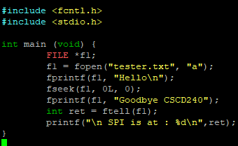

- Whether the operating system permits empty files of zero length to remain in existence after they have been closed.
Yes it seems to permit it
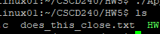
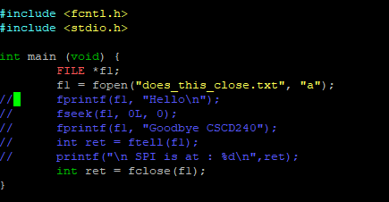

Answer (a) to (d) with code snippets and screenshots in a pdf file named HW5part1.pdf.

PART II: String Match and Empty Line Count in a Text File 8 points (4 + 4)

Specification:
You need to write a program that will read a file and a word from the command line. Next, the program will find the number of occurrences of the word in that file and count the number of empty lines too. Please find attached the C code “file.c”. You need to implement the following two functions:

int countString(const char* fileName, char *str); // counts the number of occurrences of “str” in file “fileName” 4 points int countEmptyLines(const char* fileName); // counts the number of empty lines in file “filename” 4 points

Let’s consider the content of the file named “poem.txt”
Do not go gentle into that good night, Old age should burn and rave at close of day;
Rage, rage against the dying of the light.

Though wise men at their end know dark is right,
Because their words had forked no lightning they Do not go gentle into that good night.

Good men, the last wave by, crying how bright Their frail deeds might have danced in a green bay, Rage, rage against the dying of the light.

Wild men who caught and sang the sun in flight, And learn, too late, they grieved it on its way,
Do not go gentle into that good night.

Grave men, near death, who see with blinding sight
Blind eyes could blaze like meteors and be gay, Rage, rage against the dying of the light.

And you, my father, there on the sad height, Curse, bless, me now with your fierce tears, I pray.
Do not go gentle into that good night.
Rage, rage against the dying of the light.
After you complete both of the above-mentioned functions, you can find the occurrences of the string “light” in “poem.txt” as follows:
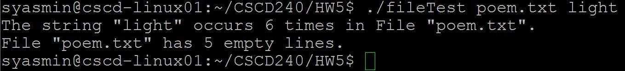
The program also finds the number of occurrences of empty lines in “poem.txt”. For empty line, you can check whether the line contains only new line (‘\n’), tab, or space.
Search should not be case sensitive. For example, search for string “Rage” or “rage” should give the same result as follows:
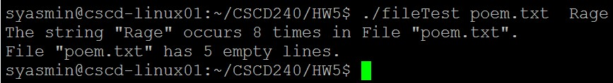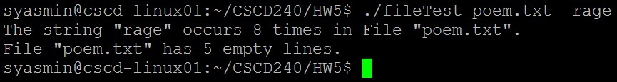

For string match, you may find the following standard library ( string.h ) function useful:
char * strstr ( const char *st, const char *sub );
‘strstr’ finds the first occurrence of the substring ‘sub’ in the string ‘st’. An example about how to use ‘strstr’ can be found to the following link: https://www.tutorialspoint.com/c_standard_library/c_function_strstr.htm

Makefile: For PARTII, you need to use Makefile; split the attached file file.c into three files: (a) header file named fileTest.h and (b) two separate source files: fileTest.c and (c) file.c. fileTest.h will only contain function declaration. For convenience, you can use additional functions. fileTest.c will contain function body. file.c will include the main function only. 4 pts

Submission:
Your final submission will be a zip file that will include the following files: fileTest.h fileTest.c……………….
file.c and
Makefile
HW5part1.pdf
Name your zip file with your last name first letter of your first name HW5.zip (ex:
yasminsHW5.zip).

Submission deadline is: 11:59 pm, Monday, March 18. No late submission will be considered.

